*RESEARCH ARTICLE*

**CONSUMPTIVE USE AND YIELD RESPONSE OF TWO INDIGENOUS**

**VEGETABLE CROPS UNDER POROUS POT SUB-SURFACE IRRIGATION**

**Ohaejesi Theodora Ogochukwu, C.D Okereke, N. A. A. Okereke,**

**C.C Egwuonwu, O.O. Okorafor, M.I. Nmecha**

Department of Agricultural and Bioresources Engineering and Environmental Management,

Federal University of Technology, Owerri, Nigeria

# ABSTRACT

In the developing world, the challenge of water scarcity (exacerbated by climate change and other demands) highlights the need to increase water use efficiency (WUE) in agriculture – including for lesser known indigenous crops. This research was aimed at investigating the Consumptive Water Use, Evapotranspiration and Yield Response of *Gongronema Latifolium* (Bush buck) and *Ocimum Gratissimum* (Scent leaves) in a Porous pot sub-surface irrigation system incorporated in to a Naturally Ventilated Poly House (NVPH). The crop plants were sown at different distances (3, 5, 7, and 9 cm) to 16 buried unglazed clay pots. Weighable lysimeters and calibrated deep stick were used to measure water use and retention and climatic data from NIMET weather station was used to model evapotranspiration for the Blaney-Morin-Nigeria (BMN) method. The findings showed a crop coefficient of 0.95 for bush buck and 0.92 for scent leaf, while the crop water requirements was 190 mm and 171 mm for the crops, respectively. Consumptive use was 0.7 and 0.5 cm/day with ET rates of 5.7 and 5.3 mm/day, respectively. Water use efficiency was significantly high: 87.7% for bush buck and 90.6% for scent leaf at 6- day irrigation interval. There was no difference in response among the treatments as determined by ANOVA. These findings underscore the potential of PCC irrigation for sustainable crop production in drought-prone areas.

**Keywords:** Indigenous irrigation, porous clay pot, sustainability, rural farming, Nigeria

***Corresponding Author***

Ohaejesi Theodora Ogochukwu

Email Address: theodora.ohaejesi@futo.edu.ng

**Received:** 2/6/2025; **Revised:** 29/6/2025; **Accepted:** 15/7/2025; **Published:** 30/7/2025

# 1.0. INTRODUCTION

Participatory rural appraisal and structured interview are two qualitative methods in use in this research work. The availability of water is closely related to climate (in particular, the amount of precipitation) and even within the country, "some periods are dry and others wet." In the last 300 years, human water use has risen 35 times (FAO, 2000). World-wide an estimated 3,240 km² of freshwater is abstracted A consumption (annual (Sally et al., 2000) of which 69 percent is used in agriculture, 23 percent in industry and 8 percent for domestic( purposes. There are large differences in water use between countries. At the global level, In South America, Asia and Africa, water is mainly consumed for agricultural purposes where 86% of the water in Asia is consumed for irrigation.

On the other hand, in the majority of the countries in North America and Europe, water needs at the homes and in industry exceed the need for agriculture. The world situation shows the tendency of resource availability> supply/ demand changing pattern resulting from increasing water demand, leading, in almost all countries, to supply and demand gap widening. Irrigation is expanding rapidly worldwide as need for food crops outstrip precipitation-fed agriculture. Population growth and increasing living standards are driving the demand for farmers produce. The water available should be used to meet the increasingly need for irrigated agriculture because in the last 20 years, the most frequent problem in tropical and sub-tropical Africa has been the drought-induced water shortage. Due to poor food and fiber production in these zones, they could not fulfil the needs of ever growing population therefore; there is food insecurity at the family level.

The heightened water scarcity for irrigation, particularly in arid and semi-arid lands (ASALS), and the need to expand irrigated areas with the same or reduced water quantities to cultivate food crops for the burgeoning population, especially in developing countries, underscore the necessity for more efficient and suitable irrigation methods (FAO, 2000). Water scarcity poses a significant threat to rural livelihoods and food security. Nigeria is endowed with a diverse array of plants of both medicinal and nutritional significance. However, many of these plant species remain underutilized due to a lack of valuable information regarding their potential as sources of substances vital to human health in terms of nutrition and medicine. Two such plants, Gongronema Latifolium (Utazi) and Ocimum Gratissimum (Nchuanwu), are the focus of this study. Rainfed agriculture is commonly characterized by low crop yields that fall significantly below potential yields and high onfarm water losses (Rockstrom, Barron &amp; Fox 2003). Therefore, enhancing crop yield under these conditions is heavily reliant on the use of irrigation water and/or maximizing yield per unit of water applied (Pereira et al. 2002). Vegetables offer smallholder farmers a considerably higher income per hectare compared to staple crops (AVRDC, 2010).

Inconsistent water supply during critical stages of crop growth can lead to a reduction in flower production, fruit drop, diminished growth and fruit set, excessive vegetative growth, delayed ripening, blossom end rot, and fruit cracking (Amjad *et al*., 2007; Le Boeuf et al., 2008). Therefore, the successful cultivation of vegetable crops in arid and semi-arid regions necessitates the implementation of full or supplementary irrigation.

## 1.1. Problem Statement

Research investigations have demonstrated that substantial initial investments, ongoing maintenance costs, and a deficiency in cultural and management skills among rural resourcepoor farmers have rendered conventional irrigation systems obsolete. An attempt was made to cultivate chili (*Capsicum annuum*) using drip irrigation, applying water at a rate of 0.36 l/s/ha, or approximately 0.3 cm/day. A primary factor contributing to reduced efficiency is water loss due to high evaporation rates, which often restrict water penetration to merely 10 cm, thereby wetting only a limited portion of the root zone. Through performance evaluations, Ikadwanto and Partowijoto identified that the water distribution efficiency of the micro-sprinkler system was significantly affected by wind velocity, pump operational pressure, and the lateral distance of the nozzle. Issues such as poor distribution, overwatering, under-watering, increased erosion, diminished downstream water quality, surface water pollution, and waterlogging are all consequences or subsequent effects of conventional irrigation systems. Weeds not only compete with crops for space in other irrigation methods but also transpire at a rate that adversely impacts the outcomes of evapotranspiration (ET) studies. The inclusion of weed transpiration values is misleading.

## 1.2. Objectives of the study

The primary objective of this study is to ascertain the water requirements and yield response of Ocimum Gratissimum (Nchuanwu) and Gongronema Latifolium (Utazi) when cultivated using a porous pot sub-surface irrigation method. The specific objectives are delineated as follows:

1. To determine the consumptive water use of the two indigenous vegetable crops under porous pot sub-surface irrigation.

1. To evaluate the wetting front radius for water distribution efficiency by varying the distance from the irrigation source during the cultivation of the two crops.

1. To assess the yield response of the two crops under porous pot sub-surface irrigation.

1. To establish the irrigation interval for the two vegetable crops.

1. To evaluate the economic significance of the porous pot irrigation system in comparison to conventional irrigation practices employed by small-scale farmers.

# 2.0. CONCEPTUAL FRAMEWORK AND LITERATURE REVIEW

## 2.1 Preview

Land and water scarcity represent significant constraints to the production of food necessary to meet the qualitative and quantitative shifts in global demand anticipated in the mid-twentyfirst century. Despite the fact that land and water resources are scarce globally, it is critical to recognize, measure, and control the significant regional and crop-specific variations (FAO, 2007). The need for more effective irrigation techniques is highlighted by the growing scarcity of water for irrigation, especially in arid and semi-arid lands (ASALS), as well as the requirement to increase the area of irrigated crops using the same or less water in order to maintain food production for the expanding population, mostly in developing nations (FAO, 2000). Since agriculture continues to be the biggest water consumer, the increased rivalry for water among urban and semi-urban areas, industries, and agriculture has put a lot of strain on it, especially irrigated agriculture (Ilesanmi, Oguntade, & Olufayo, 2012).

The problem of water scarcity brought on by the growing need for irrigation to improve the availability of food has highlighted how crucial it is to use water efficiently (Yao et al., 2013). Micro-irrigation was first proposed in 1917. Drip irrigation was first created for irrigating greenhouse crops in England, Denmark, Germany, New Zealand, and the United States. It was not until post-World War II Australia and Israel introduced low-cost, weatherresistant polyethylene plastic that it became commercially feasible (Wolff, 1999; Cui & Zornberg, 2005; Postel, Polak, Gonzales & Keller, 2001). Thus, the problem of water scarcity brought on by the growing need for irrigation to improve the availability of food has highlighted how crucial it is to use water efficiently (Yao et al., 2013). Micro-irrigation was first proposed in 1917. Drip irrigation was first created for irrigating greenhouse crops in England, Denmark, Germany, New Zealand, and the United States. It was not until postWorld War II Australia and Israel introduced low-cost, weather-resistant polyethylene plastic that it became commercially feasible (Wolff, 1999; Cui & Zornberg, 2005; Postel, Polak, Gonzales & Keller, 2001).

## 2.2 Irrigation

For humans, water is a vital natural resource. At the moment, agriculture uses around 80% of the water used for human purposes worldwide. Irrigation is the intentional application of water to soil for crop cultivation (Gurcharan, 2010). Since irrigation is the main way to increase food production to satisfy the demands of a growing population, it has gained relevance on a global scale. Although many areas also use rainfall to grow crops, the unpredictable nature of rainfall poses a serious problem. Crop yields may suffer during crucial growth times if there is either no rainfall or insufficient rainfall. Therefore, irrigation is the only way to guarantee that crops receive a sufficient and timely quantity of water. Groundwater and surface water are the two main sources of irrigation water. The science of designing, managing, and maintaining irrigation systems to maximize the use of available water resources is known as irrigation. According to Gurcharan (2010), this entails building infrastructure like dams, reservoirs, canals, headworks, cross-drainage structures, and river training projects. When rainfall is insufficient, such as when it is little or sporadically distributed over the crop maturity period, or when growing cash crops and other commercial crops that need a lot of water, irrigation is especially important.

### 2.2.1 Irrigation Methods

Surface (or flood), sprinkler, trickle, and subsurface irrigation are the four main ways that irrigation water is applied. Among the surface irrigation techniques are furrow, basin, border, contour levee, and contour ditch methods. Sprinkler and trickle irrigation are applied to the soil surface, while subsurface irrigation is applied directly to the root zones below the soil surface. Several criteria are often examined while selecting an appropriate irrigation method, such as land slope, the soil's water intake rate (i.e., the rate at which the soil absorbs applied water), the water tolerance of the crops, and wind conditions. For example, soils with low water intake rates, like fine soils, may benefit from sprinkler, surface, or trickle irrigation, whereas soils with high water intake rates, like coarse soils, may not benefit from surface irrigation. Soil texture, compaction-induced surface sealing, soil and/or irrigation water salt concentration, and irrigation water electrical conductivity are important factors that influence water intake rates (Gurcharan, 2010; Duhrkoop, 2011).

2.2.2 Systems of Irrigation

The controlled application of water for agricultural uses using artificial systems to satisfy water needs not satisfied by rainfall is known as irrigation. In arid climates, this technique— which involves artificially adding water to land—is essential for successful large-scale agricultural production (Tripathi, Sharma & Meena, 2017). When bigger regions require irrigation, more sophisticated water application techniques are used. Surface, drip, and sprinkler irrigation are the three main techniques that are frequently used (FAO, 2000). The water source, pump, backflow prevention, pressure regulator, filter, injector, adapters, distribution lines, sub-main lines, emitters, and filter are all crucial parts of an irrigation system (Michael 2006).

2.2.3 Irrigation System Types

1. There are numerous irrigation systems, each with unique techniques for distributing water around fields. Typical irrigation systems consist of:
2. Surface Irrigation: This method involves the distribution of water over the land by gravity, without the use of mechanical pumps.
3. Localized Irrigation: Water is delivered under low pressure through a network of pipes, targeting individual plants.

6

1. Drip Irrigation: Also known as micro-irrigation, this is a form of localized irrigation where water is delivered in droplets at or near the plant roots. This method minimizes evaporation and runoff, significantly reducing conveyance and application losses. Variants of this system include conventional drip systems, indigenous pot drips, subsurface drips, bucket drip kits, micro tubes, and family drip kits, which are particularly prevalent in India.
2. Sprinkler Irrigation: Water is distributed overhead using high-pressure sprinklers or guns, either from a central location in the field or from sprinklers mounted on mobile platforms.
3. Center Pivot Irrigation: This system employs sprinklers mounted on wheeled towers that move in a circular pattern, commonly used in flat terrains.
4. Lateral Move Irrigation: Water is distributed through a series of pipes, each equipped with a wheel and a set of sprinklers that are manually or mechanically rotated. The system requires periodic reconnection of the water hose as the sprinklers move across the field. Although less costly, it demands more labor compared to other systems.
5. Unglazed Clay Pot Sub-surface Irrigation: Water is distributed through micropores in the walls of clay pots buried neck-deep in the ground. When filled with water, these pots facilitate sub-surface irrigation as water seeps out due to the suction force attracting water molecules to the plant roots.
6. Sub-irrigation: This method involves raising the water table through a network of pumping stations, canals, gates, and ditches, proving most effective in areas with a high water table.
7. Manual Irrigation: Water is distributed manually across the land using watering cans, a labor-intensive method (Michael, 2006).

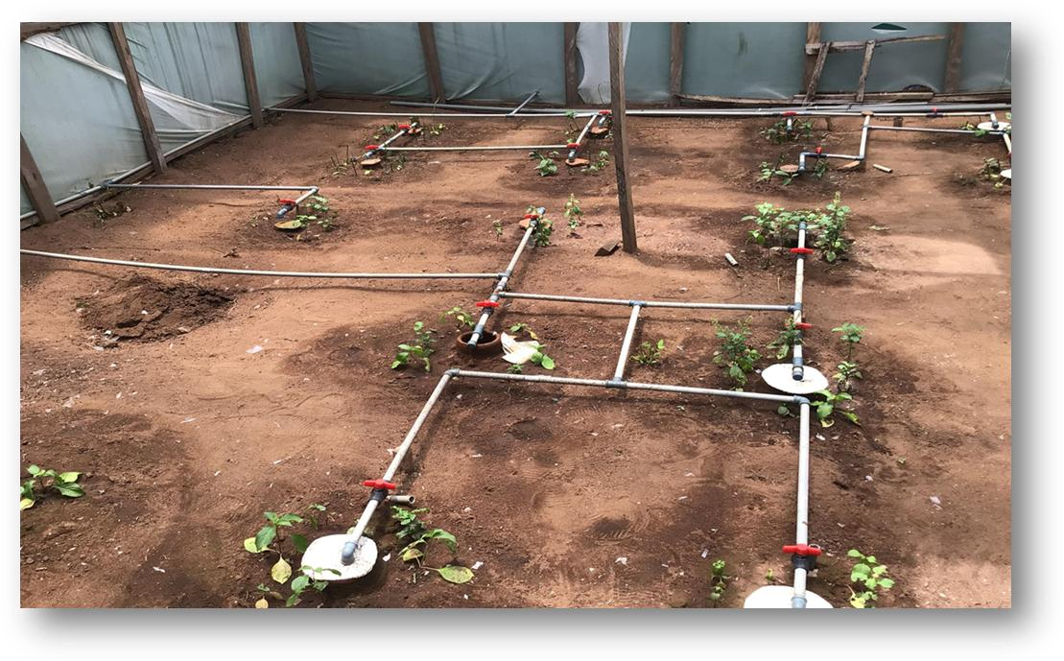

Plate 1: Porous Clay Pot Experimental Set up

7

# 3.0. MATERIALS AND MMETHODOLOGY

The materials employed in this study included instruments for soil testing and analysis within a laboratory setting, as well as cultivation tools such as shovels, rakes, hoes, calibrated deep sticks, and machetes for preparing the area designated for sub-surface irrigation. Additionally, locally made clay pots and vegetable crop seedlings of Ocimum gratissimum (scent leaf) and robust, greenish vines of Gongronema latifolium (utazi) were utilized. A weighing lysimeter was established to measure crop evapotranspiration, and an electronic weighing balance was employed to weigh the lysimeter before and after the irrigation of the two vegetable crops.The naturally ventilated polyhouse (NVPH) that accommodated the experimental setup was constructed using locally sourced wooden materials (2’x2’x18, 2’x4’x18), bundles of batin, mosquito nets, nails, and various grades of polyethylene to prevent external precipitation and interference.The porous clay pots were procured from local female artisans in Ishiagu, Ebonyi State, Nigeria. These unpolished or unglazed clay pots, used in this study, ranged in volume from 2.0 L to 3.0 L, with a height of approximately 0.28 m and a thickness of 1 cm. The inlet opening diameters varied between 26.6 mm and 121 mm, featuring a flat base (Figure 3.1).

The neck region of each porous pot was positioned approximately 2 cm above ground level to facilitate field observation and was equipped with a lid to deter rodents and reptiles. These pots were also fired in a kiln at approximately 100 °C locally after production.The NVPH utilized conformed to agronomic selection criteria, facilitating continuous plant growth. The tender shoots and creeping vines of the vegetable crops were sourced locally from existing farms. Tender shoots of the scent leaf (S2) were harvested and planted in the nursery, while the robust green vines of the Utazi (S1) leaves were also harvested. These were subsequently cut into lengths of approximately 10 cm, each containing at least one node, to promote development upon direct planting in the nursery.A weighing lysimeter, a cylindrical apparatus with a depth of approximately 0.37 m and a diameter of 0.31 m, was employed to estimate crop evapotranspiration (ETc) during the experiment. A 10-liter container served as a drain water collector, connected to the lysimeter cultivating tank via a 0.2 mm hose pipe. An electronic weighing balance was used to measure the differences in soil weight before and after irrigation.

## 3.1.2 Study Area

The field experiment was conducted within a naturally ventilated polyhouse (NVPH) over a single growing season in the Avu community, proximate to the Federal University of Technology (FUT) Owerri West, Imo State. The study area is geographically situated between latitudes 4˚45’N and 7˚15’N and longitudes 6˚50’E and 7˚25’E, encompassing an area of approximately 5,100 square kilometers. The region experiences an average annual temperature exceeding 20 °C (68.0 °F), resulting in an annual relative humidity of 75%, which escalates to 90% during the rainy season. The topography is predominantly undulating, and the soil is characterized as oxisols with a sandy loam to loamy surface texture (Egbuchua, 2007). The mean annual rainfall ranges from 1500 to 2250 mm, occurring from April to November. The area benefits from more concentrated and available rainfall for agricultural activities between March and September, while experiencing a dry and harmattan season from November to mid-February. The hottest months are recorded between January and March.

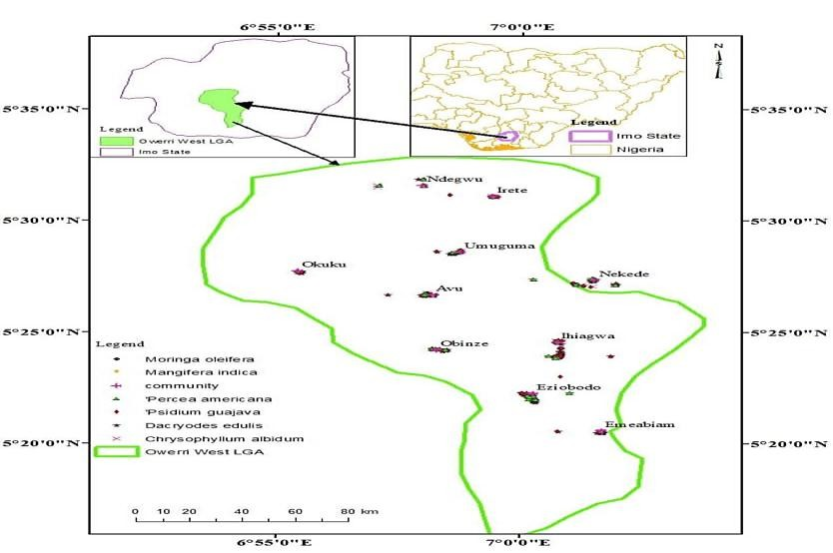

Figure 3.1: Map of the Study Area

Source: Adeyemi, Okwu & Ekeada (2015).

# 4.0. PRESENTATION OF RESULTS AND DISCUSSIONS

## 4.1. Presentation of Results

Tables and Figures

Farmers reported a 60 percent increase in crop frequency and 45 percent increase in income over seasonal cultivation.

Table 1: Daily Water Remains in Each Buried Clay Pot (in Litres) During the Experiment

|  |  |  |  |  |  |  |  |  |  |  |
| --- | --- | --- | --- | --- | --- | --- | --- | --- | --- | --- |
|  |  |  |  | **Utazi Leaf** | | |  |  |  |  |
| Pots | 11/6/24 | 12/6/224 | 13/6/24 | 14/6/24 | 15/6/24 | 16/6/24 | 17/6/24 | 18/6/24 | 19/6/24 | 20 /6/24 |
| 1 | 0.0 | 0.6 | 0.5 | 0.4 | 0.4 | 0.45 |  | 0.6 | 0.5 | 0.5 |
| 2 | 0.0 | 0.5 | 0.4 | 0.5 | 0.6 | 0.5 | 0.6 | 0.52 | 0.4 | 0.5 |
| 3 | 0.0 | 0.4 | 0.5 | 0.38 | 0.4 | 0.6 | 0.5 | 0.48 | 0.5 | 0.42 |
| 4 | 0.0 | 0.3 | 0.35 | 0.4 | 0.4 | 0.38 | 0.5 | 0.4 | 0.48 | 0.45 |
| 5 | 0.0 | 0.4 | 0.45 | 0.6 | 0.7 | 0.48 | 0.6 | 0.5 | 0.7 | 0.5 |
| 6 | 0.0 | 0.0 | 0.0 | 0.0 | 0.0 | 0.0 | 0.0 | 0.0 | 0.0 | 0.0 |
| 7 | 0.0 | 0.1 | 0.3 | 0.3 | 0.4 | 0.35 | 0.2 | 0.4 | 0.3 | 0.35 |
| 8 | 0.0 | 0.5 | 0.7 | 0.6 | 0.7 | 0.3 | 0.4 | 0.3 | 0.4 | 0.43 |
|  |  |  |  | **Nchuanwu Leaf** | |  |  |  |  |  |
| 9 | 0.0 | 0.3 | 0.3 | 0.25 | 0.3 | 0.2 | 0.25 | 0.3 | 0.25 | 0.28 |
| 10 | 0.0 | 0.2 | 0.2 | 0.1 | 0.3 | 0.2 | 0.2 | 0.15 | 0.2 | 0.15 |
| 11 | 0.0 | 0.3 | 0.2 | 0.2 | - | 0.3 | 0.4 | 0.2 | 0.3 | 0.2 |
| 12 | 0.0 | 0.2 | 0.22 | 0.2 | 0.2 | 0.25 | 0.2 | 0.23 | 0.18 | 0.15 |
| 13 | 0.0 | 0.3 | 0.32 | 0.4 | 0.4 | 0.35 | 0.3 | 0.4 | 0.26 | 0.4 |
| 14 | 0.0 | 0 | 0 | 0 | 0 | 0 | 0 | 0 | 0 | 0 |
| 15 | 0.0 | 0.5 | 0.4 | 0.5 | 0.2 | 0.5 | 0.4 | 0.5 | 0.2 | 0.2 |
| 16 | 0.0 | 0.3 | 0.4 | 0.7 | 0.4 | 0.6 | 0.6 | 0.7 | 0.3 | 0.38 |

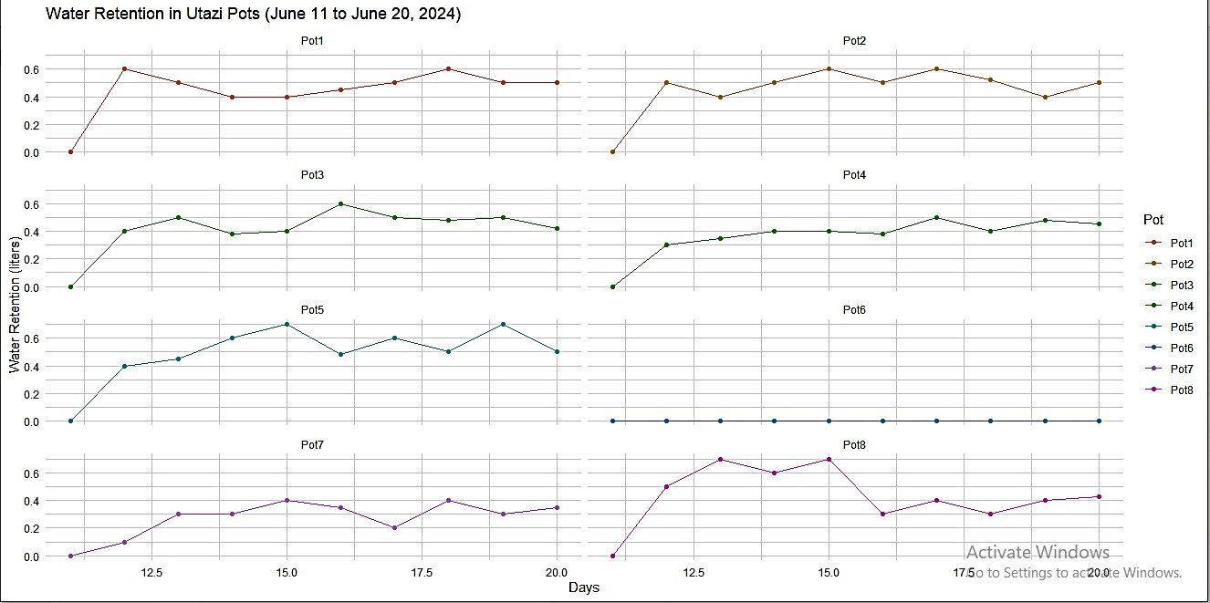

Figure 1: *Utazi* leaf Water Retention from June 11 to June 20, 2024

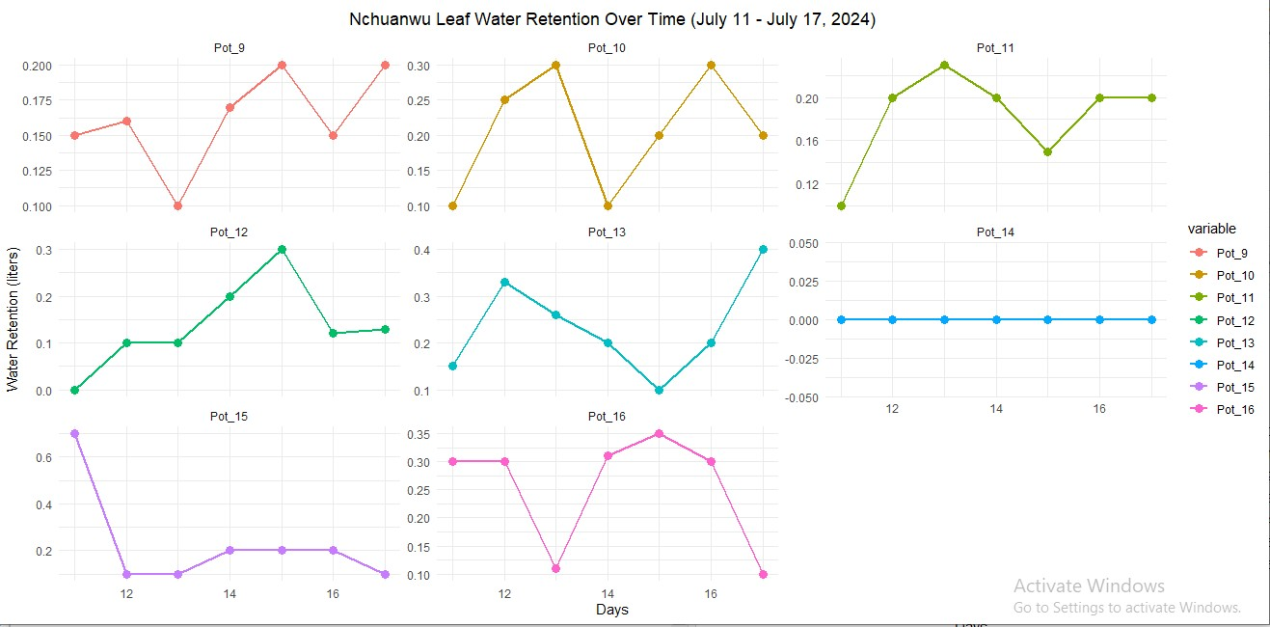

Figure 2: *Nchuanwu* Leaf Pots (9-16) from July 11 to July 17, 2024.

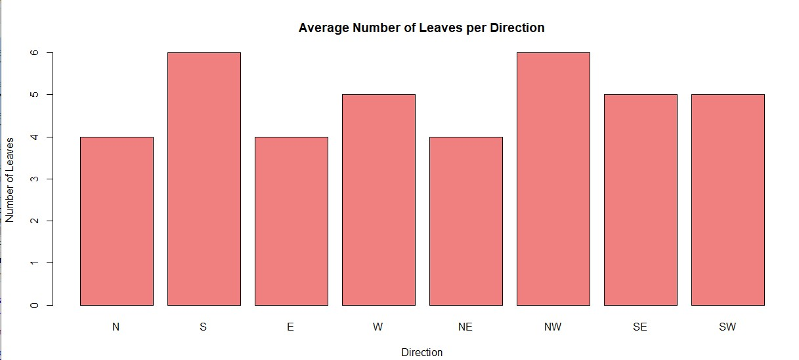

Figure 3a: Number of Leaves at Different Coordinate Direction



Figure 3b: Average Number of Leaves per Coordinate Direction

## 4.2. Discussion of Findings

The study assessed the cultural appropriateness and economic viability of the porous pot system. Significant differences were observed in the water retention statistics for both *Utazi* and *Nchuanwu* leaves between June 11 and July 17, 2024. Overall water retention for *Utazi* leaves was continuously low; on July 12, the highest figure was 0.31 liters in Pot 7. Pot 6 was one of several pots that continuously showed zero retention, indicating possible problems with the plant or the soil. Significantly, Pot 2 demonstrated modest gains, reaching 0.2 liters on July 15, suggesting sporadic efficacy in moisture retention.

On the other hand, the water retention of the *Nchuanwu* leaves varied more. In comparison to *Utazi* pots, Pot 10's better ability for moisture absorption was demonstrated by its peak of 0.3 liters on July 15 during the same time period. Furthermore, on July 17, Pot 13 reached a peak of 0.4 liters, demonstrating its efficient water retention. But like Utazi, Pot 14 had a 0% retention level for the duration of the observation, suggesting problems that might need more research. Overall, the results showed that although Nchuanwu leaves typically held more

water—values often reaching 0.8 liters or more—than Utazi leaves, which had a maximum of 0.31 liters, both species showed variability across pots. These findings highlight how crucial it is to keep an eye on soil and environmental conditions because changes in water retention can have a big impact on plant development and health. In order to improve irrigation techniques and the general management of both crops in agricultural settings in the future, such insights are essential.

# 5.0. CONCLUSION AND RECOMMENDATIONS

To achieve the objectives outlined in this study, it is recommended to pursue policy support and community-scale implementation. This research has substantiated the efficacy of porous subsurface irrigation for two indigenous crops: bush buck (*Utazi*) and scent leaf (*Nchuanwu*). The crop water requirements were established at 190 mm for *Utazi* and 171 mm for *Nchuanwu*, providing a dependable foundation for irrigation planning and water resource management. Water Use Efficiency (WUE) was notably high, with 90.6% for *Nchuanwu* and 87.2% for *Utazi*, indicating efficient biomass production per unit of water. The crop consumptive use was estimated at 0.5 cm/day for *Utazi* and 0.3 cm/day for *Nchuanwu*, which is instrumental for water budgeting. The optimal irrigation interval was determined to be every 6 days, facilitating reduced irrigation frequency and water conservation. The observed yield patterns corroborated the consistency and viability of this irrigation method, presenting scalable options for precision agriculture and food security initiatives in water-scarce regions.

To further enhance the system, the following recommendations are proposed: (a). The planting distance should be increased to 23 cm to correspond with the wetted zone of the buried pots (~25 cm). (b). The irrigation intervals should be extended to 2–4 days using larger clay pots (5–7 liters). (c). Future researchers should conduct year-long research to obtain more robust data on annual crop water use. (d). Photosynthesis and transpiration rates should be measured to gain deeper insights into crop water dynamics. (e). Conventional irrigation should be included as a control for performance comparison. (f). Increasing replications and randomization can enhance the statistical power of the findings. (g). The system's viability for commercial farming in the region should be assessed. (h). Soil moisture and water-holding capacity should be monitored to evaluate their impact on crop performance and water use

## 6. Contribution to Knowledge

This research advances the scientific understanding of indigenous crop irrigation through the following contributions:

For the first time, crop coefficient (Kc) values have been determined for *Utazi* (0.95) and *Nchuanwu* (0.92). Consumptive use rates have been established: 0.7 cm/day for *Utazi* and 0.5 cm/day for *Nchuanwu*. The wetted area of the clay pots was approximately 7986.37 mm², justifying a planting distance of up to 25 cm. An irrigation interval of 6 days was identified based on a 30 mm rooting depth. Quantified crop water requirements have been provided:

190 mm for *Utazi* and 171 mm for *Nchuanwu*.

**Competing Interest**

The authors have declared that no conflicting interest exist in this manuscript.

# REFERENCE

Adeyemi, D., Okwu, M. O., & Ekeada, C. N. (2015). Mapping and Geo-environmental Analysis of Avu Region*.* *Journal of Environmental Management Studies, 3*(2), 44 –51.

Amjad, M., Ahmad, R., & Imran, M. (2007). Effects of different irrigation levels on yield and quality of tomato. *Journal of Agricultural Research*, *45*(2), 105 – 111.

AVRDC – The World Vegetable Center. (2010). *Vegetables for poverty alleviation and healthy diets*. Shanhua, Taiwan: AVRDC Publication.

Chapin, F. S. (2000*).* The rise of drip irrigation in the United States: Historical overview and recent innovations. *Agricultural Technology Review, 21*(3), 67 – 75.

Cui, Y., & Zornberg, J. (2005). Use of geosynthetics in agriculture. *Proceedings of the 16th International Conference on Soil and Water Conservation*.

Duhrkoop, D. (2011). *Soil–water relations in agricultural irrigation*. Iowa State University Extension Bulletin.

Egbuchua, C. O. (2007). Pedological characteristics of selected wetland soils in Delta State, Nigeria. *Journal of Agriculture and Social Research*, *7*(2), 25 – 30.

FAO. (2000). *Agriculture towards 2015/2030*. Rome: Food and Agriculture Organization of the United Nations.

FAO. (2007). *Coping with water scarcity: Challenge of the twenty-first century*. United Nations World Water Day Report.

Gurcharan, S. (2010). *Irrigation Engineering and Hydraulic Structures.* 20th Edition. Delhi: Standard Publishers Distributors.

Ikadwanto, F., & Partowijoto, S. (2013). Performance efficiency of micro-sprinkler irrigation under different wind and pump pressures*.* *Indonesian Journal of Irrigation Engineering*, *15*(1), 21–28.

Ilesanmi, F. F., Oguntade, A. E., & Olufayo, A. A. (2012). Water demand management and irrigation development in Nigeria. *Journal of Water Resources and Protection*, *4*(6), 456–461. <https://doi.org/10.4236/jwarp.2012.46052>

INCID. (1994). *Drip Irrigation in India*. Indian National Committee on Irrigation and Drainage, New Delhi: Government of India.

Le Boeuf, B., Mukhala, E., & Hainsworth, S. (2008). Irrigation scheduling for smallholder farmers*. South African Journal of Agricultural Engineering, 34*(4), 101–109.

Michael, A. M. (2006). *Irrigation: Theory and Practice.* 2nd Edition. New Delhi: Vikas Publishing House.

Pereira, L. S., Oweis, T., & Zairi, A. (2002). Irrigation management under water scarcity.

*Agricultural Water Management*, 57(3), 175–206. [https://doi.org/10.1016/S0378](https://doi.org/10.1016/S0378-) 3774(02)00075-6

Postel, S., Polak, P., Gonzales, F., & Keller, J. (2001). Drip irrigation for small farmers: A new initiative to alleviate hunger and poverty. *Water International*, *26*(1), 3–13. <https://doi.org/10.1080/02508060108686882>

Rockström, J., Barron, J., & Fox, P. (2003). Water productivity in rain-fed agriculture: Challenges and opportunities for smallholder farmers in drought-prone tropical agro-ecosystems. *Water Productivity in Agriculture: Limits and Opportunities for Improvement*, 145–162.

Sally, H., Abernethy, C. L., & Lankford, B. A. (2000). Water management and irrigation development in sub-Saharan Africa*.* *IWMI Research Report No. 38 of the International Water Management Institute*.

Tripathi, R. P., Sharma, V. K., & Meena, R. P. (2017). *Modern techniques of irrigation water management*. New Delhi: New India Publishing Agency.

Wolff, P. (1999). Water management in agriculture: Challenges in the 21st century. *Proceedings of the International Water Management Symposium, Berlin*.

Yao, R., Wei, W., Chen, L., & Wang, L. (2013). Effects of land use and vegetation cover on soil moisture in the Loess Plateau, China. *Catena*, *101*, 62–69. https://doi.org/10.1016/j.catena.2012.10.013